CHAPTER 4

ANALYSIS AND DESIGN

Use Case Specification and UML Diagrams
Login and Authentication

4.1 Introduction
This document presents the detailed design of the first use case of the PSM Assessment System, namely Login and Authentication. It shows how the use case identified in the use case diagram is refined into a use case specification, a sequence diagram and an activity diagram. The use case is described first, then each diagram is presented and explained step by step.

4.2 Use Case Specification
The Login and Authentication use case allows any registered user to sign in. It is the entry point to every other use case in the system, because all remaining use cases require an authenticated user whose role determines what the user may access. Table 4.1 summarises the use case.
Table 4.1: Use Case Specification for Login and Authentication
Use Case ID | UC-01
Use Case Name | Login and Authentication
Actor | Student, Admin, Supervisor, Lecturer, Panel, Coordinator, System Controller
Description | The user signs in with an email address and password. The system verifies the credentials, checks that the account is not locked and is active, then issues an access token and redirects the user to the dashboard for their role.
Pre-condition | The user has a registered account in the system, and the account has been activated by the administrator.
Trigger | The user opens the Login page and submits their email and password.
Main Flow | 1. The user opens the Login page.  2. The user enters an email address and password.  3. The user clicks Login.  4. The system validates the input format.  5. The system finds the account for that email address.  6. The system verifies the password against the stored hash.  7. The system confirms the account is active.  8. The system creates an access token for the session.  9. The system records the successful login in the audit log.  10. The system returns the token, the user details and the landing route for the user's role.  11. The user is redirected to the role dashboard.
Alternative Flow | A1. Input invalid: at step 4, the system displays an input error message and returns to step 2.  A2. Account not found: at step 5, the system logs the failed attempt and returns a general authentication failure message, without revealing whether the email is registered.  A3. Account locked: the system returns a message stating that the account is temporarily locked.  A4. Password incorrect: at step 6, the system increases the failed attempt counter, logs the failure and returns a general authentication failure message. After five consecutive failures the account is locked for fifteen minutes, and the lock duration doubles on each further block.  A5. Account not active: at step 7, the system returns a message stating that the account is suspended, inactive or not yet verified.
Post-condition | On success, the user holds a valid access token and is signed in, and the login is recorded in the audit log. On failure, no token is issued, the failure is recorded, and the user remains on the Login page.

Several design decisions in Table 4.1 follow good practice for authentication. The failure messages for an unknown account (A2) and for an incorrect password (A4) are deliberately identical, so that an attacker cannot use the login form to discover which email addresses belong to students or staff. The failed attempt counter (A4) limits password guessing, and the lockout duration increases on each repeat so that a persistent attacker is slowed progressively rather than merely delayed.

4.3 Sequence Diagram
The sequence diagram in Figure 4.1 shows the same flow as an ordered exchange of messages between the objects involved. Four lifelines are used: the actor, the Login interface, the authentication controller, and the user model with its database. The diagram is divided into the sign-in attempt and what happens once it is accepted.
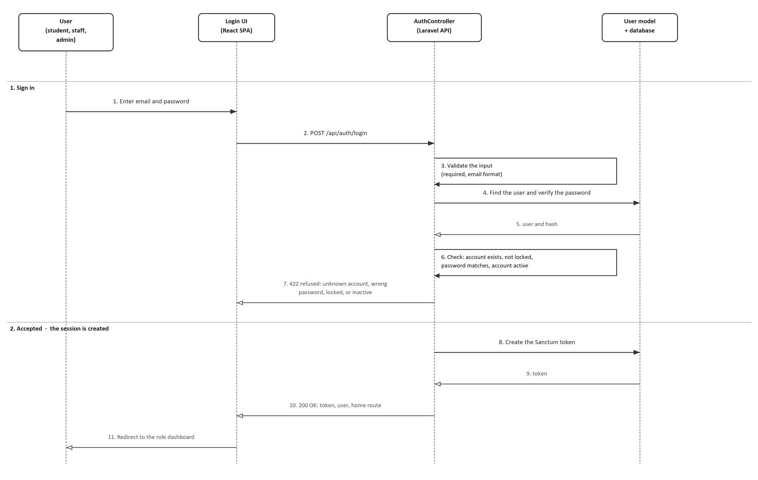
Figure 4.1: Sequence Diagram for Login and Authentication
Messages 1 and 2 carry the credentials from the actor, through the Login interface, to the controller. Message 3 validates the input, which corresponds to step 4 of the main flow, and message 4 looks the account up and verifies the password. Message 6 is the single decision that produces every refusal the use case has: an unknown account, a wrong password, a locked account or an inactive one are all alternative flows A2 to A5, and all of them leave through message 7. They are drawn as one decision rather than four because they are one answer to the reader — the credentials did not pass — and Table 4.1 separates them.
Only when message 6 passes does the accepted half of the diagram run: message 8 creates the access token, which also resets the failed attempt counter and records the login time and address, and message 11 sends the user to the dashboard for their role.

4.4 Activity Diagram
The activity diagram in Figure 4.2 presents the same use case as a workflow. It is useful because it shows where the refusal leaves the main path and where it re-enters it, which the sequence diagram expresses less directly.
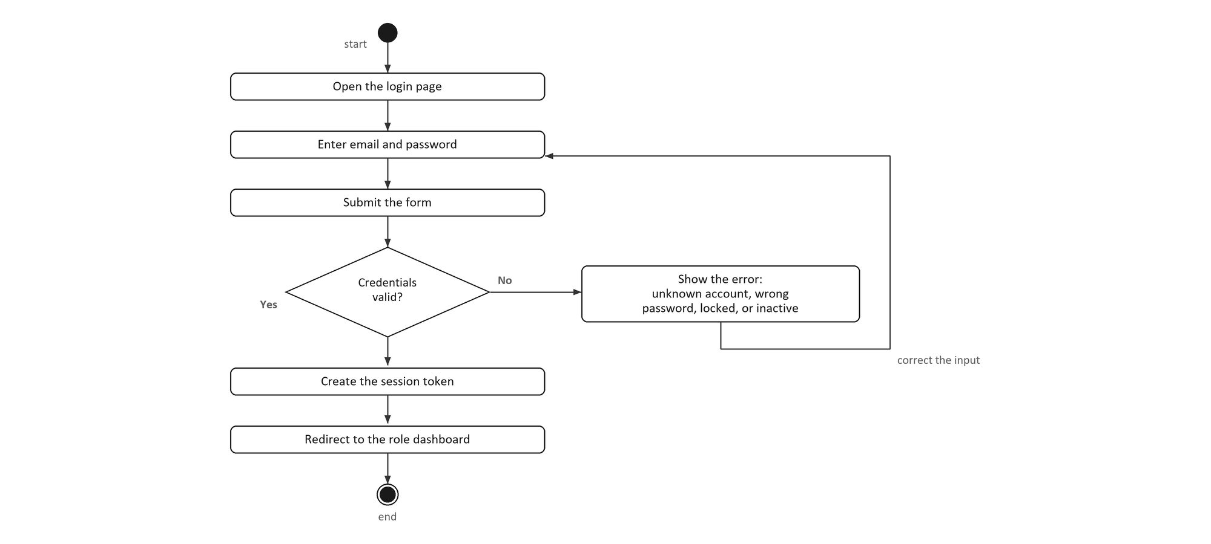
Figure 4.2: Activity Diagram for Login and Authentication
The workflow passes through three interface activities — opening the Login page, entering the email address and password, and submitting the form — and then reaches the one decision the use case turns on: are the credentials valid?
The No branch shows the error and returns to the form, so the user may try again. It names the four refusals in a single line rather than as four separate branches; the alternative flows in Table 4.1 are where each one is specified. The Yes branch creates the session token and redirects the user to the dashboard for their role, after which the flow reaches the end node.

4.5 Chapter Summary
This document has specified the Login and Authentication use case and presented its sequence diagram and activity diagram. The use case specification defines the actors, the main flow, the five alternative flows and the pre-conditions and post-conditions. The sequence diagram shows the same flow as message exchanges between four objects, and the activity diagram shows it as a workflow with one decision point. The remaining use cases identified in the use case diagram — Manage Title and Registration, Manage Milestone, Manage Evaluation, Generate Report, and Manage Alert and Notification — follow the same documentation approach.

